**Graphical dice**

## **Step 1: Make it**

### **What is it?**

A dice project that looks like a real die with patterns of dots instead of numbers.

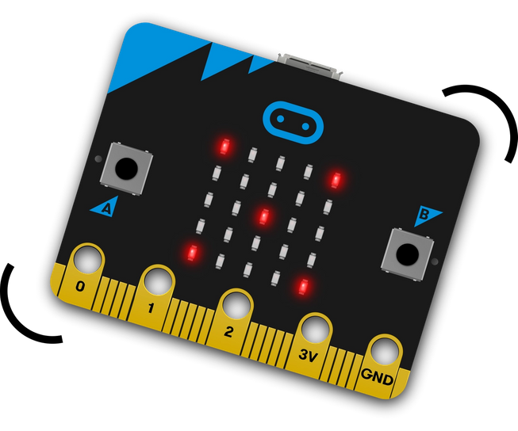

### **How it works**

* Like the Dice project this uses the accelerometer input to trigger the creation of a random number between 1 and 6 and show it on the LED display output when you shake the micro:bit.
* Instead of showing a number, this program uses **selection** to show dots on the display to **represent** the numbers, looking like the dots on each face of real dice, depending on which random number was generated.

### **What you need**

* micro:bit (or MakeCode simulator)
* MakeCode or Python editor
* battery pack (optional)
* squared paper for designing your own dice faces (optional)

## **Step 2: Code it**

## **Step 3: Improve it**

* Make the display clear after a few seconds to make the batteries last longer and to make it clear when you have rolled two numbers the same.
* Draw your own dot patterns to represent each number.
* Make it roll higher numbers. How would you represent them on the 5x5 LED grid display output?